**Executive Summary**

Big Mountain Resort wants to determine if they can increase their ticket prices based on the facilities and services they offer compared to competitors. US resorts’ ticket price and resort amenity data were collected and analyzed to build a predictive pricing model and make pricing recommendations.

**Data Wrangling**

The raw data contained 330 rows with information on ski resorts and their various facilities, amenities and pricing. Key data wrangling steps included:

- Removed 15 rows with missing price data that could not be used in the analysis

- Removed the 'fastEight' column which was missing data for over 50% of resorts

- Corrected erroneous values for 'SkiableTerrain_ac' and 'Snow Making_ac' based on research

- Removed one row for a resort that is not yet opened

After cleaning, 279 rows remained with 25 columns describing resort characteristics to be used in modeling.

**Exploratory Data Analysis**

Scaled the data and performed PCA to visualize relationships between resorts and states. No clear clusters or groupings emerged based on state. There were some observed state-level differences:

- New York has the most resorts but they are smaller in skiable area

- Vermont and New Hampshire have a higher density of resorts serving the population

- Ski resort ticket prices vary significantly within states

At the resort level, there were a number of observed relationships with ticket price (Graph 1):

- Ticket price increases with skiable area, vertical drop, and snow making capabilities

- Resorts with more chairs and runs can charge higher prices

- Higher prices for resorts with a larger share of the state's total night skiing area

Graph 1: Heatmap of correlations between Adult Weekend Prices and features

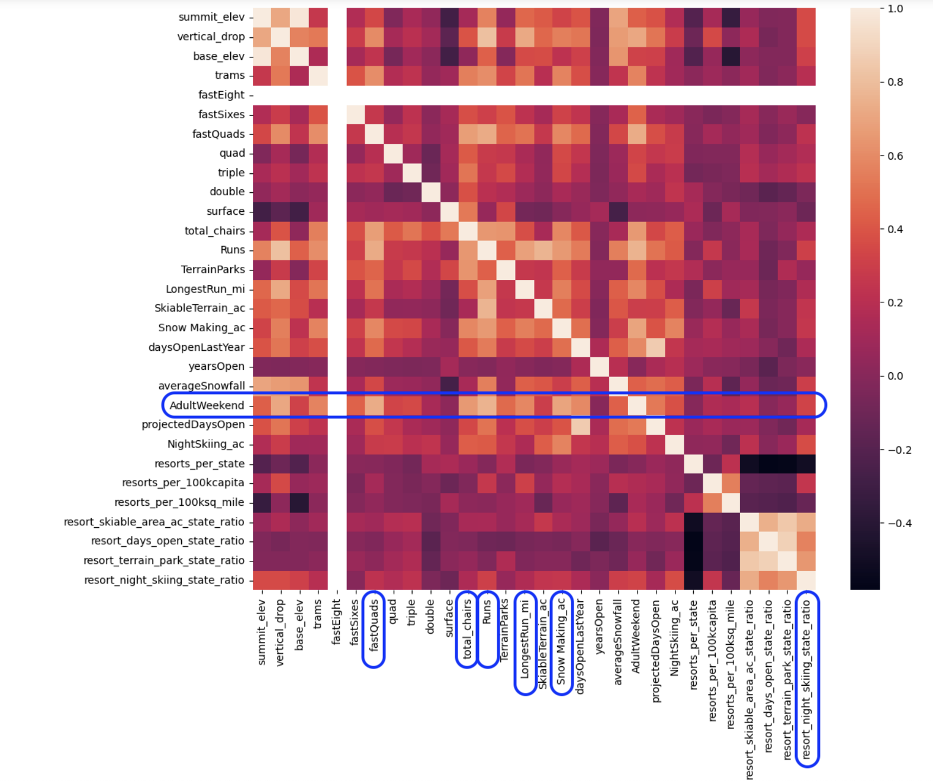

**Model Building and Results**

A random forest model was built to predict ticket price based on resort characteristics. The model was tuned using GridSearchCV and evaluated using 5-fold cross-validation. The final model has a MAE of $10.28 +/- $0.74 on the train set and a MAE of $9.02 on the held-out test set.

The most important features driving predicted price are:

1. fastQuads

2. Runs

3. Snow Making_ac

4. vertical_drop

Using this model, Big Mountain's facilities support a ticket price of $93.22 compared to their actual price of $81.00. This suggests they are underpriced by over 15% compared to market rates for their facilities.

Several what-if scenarios were modeled such as closing runs or adding lifts and snow making capabilities. Adding a lift to increase the vertical drop by 150 ft could support a $0.54 price increase worth nearly $1M in additional annual revenue.

**Recommendations**

Based on the model results, Big Mountain Resort should consider:

1. Increasing their weekend adult ticket price from $81 to $93, a 15% increase, to align with market rates for their facilities and services.

2. Investing in a new lift to increase the vertical drop and add a run, supporting a $0.54 price increase worth $1M in projected revenue.

3. Not investing in expanding terrain or adding new chairs/lifts, as modeling showed no price gains from these improvements.

4. Closing up to 5 of their least used runs, which is predicted to have minimal impact on supported price.

**Next Steps**

Further work to refine the pricing model could include:

- Collecting additional data on actual operating costs, number of visitors, and competitor pricing to refine the model

- Analyzing pricing on different ticket types and time frames (weekday, season passes, etc.)

- Conducting in-depth customer research on willingness to pay at different price points

- Building an interactive pricing simulator for executives to easily explore different scenarios

By using data to understand the market and align their prices and investments accordingly, Big Mountain Resort can optimize their revenue and profitability going forward.